Automated Plant Watering System using Soil Moisture Sensor and Rain Sensors
Farhan Ahmed1, Jahanara Akter¹, Md.Tariq Hasan1, Shadman Shahriar Hasan Arko1

1 Department of Computer Science & Engineering, BRAC University, Mohakhali,
66 Bir Uttam AK Khandakar Road, Dhaka 1212, Bangladesh
{sfa.pranto,jahanaraakter1996,mdtariqhasan99,shadman.arko}@gmail.com
Abstract. With the exponential rise of air pollution levels and advancements in the technological industries, the world’s forest and plant populations are at risk. Well renowned organizations such as Natural Resources Defense Council alongside thousands of passionate Horticulture Cultivators and Gardeners are hard at work to keep the world eco-friendly. However, we understand that at times it might get extremely difficult for single individuals to properly manage and tend to a large plant set-up such as a garden or a farm. This is especially true if you factor-in the daily labor of watering hundreds of plants twice! The Automated Watering Device proposed in this paper aims to solve that problem by measuring the moisture of the soil (at root level) with pin-point accuracy and automatically water the plant when needed.
1 Introduction
The significance of having localized farms and gardens that are designed to cultivate plants has never been greater. The world is going through an age of industrial and technological revolution, which indirectly means that the large manufacturing moguls are using up Earth’s resources at a faster rate than she can produce. Expectedly, Earth’s plant life and forests are taking a heavy toll due to the exponentially increased rate of timber required by the industries and the amount of air pollution caused by them. Fortunately though, a number of different worldwide conservation and environmental organizations such as Earth Island Institute alongside exceptionally hardworking farmers and gardeners are doing their best to keep the world eco-friendly.

That being said, it should be fully understood and appreciated that both a large or small scale plant based set-up requires a good watering system, in order to keep the plants well fed. Without a proper and consistent supply of water, plants will die. This may not be a major problem for large industries with thousands of employees, but for a lone farmer or a garden hobbyist, watering and taking care of a large plant settlement can become extremely difficult. The proposed model discussed in our paper is designed to provide such individuals a cheap and efficient mechanism that would help them automatically water their plants, without human supervision. This is achieved through a mechanism that accurately measures the moisture of the soil in order to determine if the plant requires water or not.

The rest of this paper is organized as follows: Section 2 discusses the literature review of the paper. Section 3 describes details on the proposed model. The results and discussion is presented in Section 4 and finally Section 5 concludes the paper.
2 Literature Review
For the proper implementation of our technology, detailed understanding of the properties of soil and its moisture sustaining capabilities alongside a plant’s requirements for healthy growth were needed. As discussed in [2], defining soil moisture is rather tricky because its core definition seems to differ from one discipline to the next. In terms or horticulture, soil moisture is the water that is held in the spaces between individual soil particles. When trying to detect soil moisture, two different types of moisture are to be generally considered. Surface soil moisture is the water that is in the upper 10 cm of soil, while the root zone soil moisture is the water that is actually available to plants at root level. Our device aims to make its judgments by carefully reading the soil moisture at root level.

The amount of water held by soil is generally referred to as “Volumetric Water Content” (VWC) as discussed in [3], and is expressed as a percentage or ratio (inches of water per inch of soil). For example, one cubic foot of soil with 30% VWC contains 0.3 cubic feet, or 2.25 gallons of water. However, the values will change depending on the tight of soil that is used. Soil with small particles holds on to water more tightly than sandy soil, which that may lead to different readings [7].

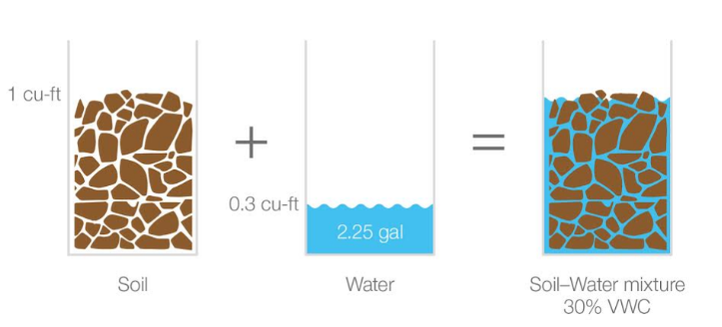

Fig. 1. Illustrated example of Volumetric Water Content

Keeping that in mind, in this paper we have presented a simple and easy to use device that accurately measures soil moisture at root levels and automatically waters the plant when needed. The device is designed keeping the most general audience in mind, therefore it is constructed to be as accessible as possible. To keep costs low, the Raspberry Pi 3 Model B+ (with Raspbian installed) is used as the main microcomputer that receives the readings and processes them accordingly. The actions of the individual sensors and data are processed through simple scripts written in Python 2.7. We realize that there were far cheaper options such as the Arduino line of Microcomputers’; however the decision of using the more advanced Raspberry was made with the future in mind. The prototype that we have created is demonstrated by using only a single plant, but in the future, we hope that individuals will use this device to plan hundreds of even thousands of plants simultaneously. The updated Broadcom processor, which boasts ARM architecture, alongside multiple networking options make this chipset an extremely power efficient and suitable option for future scaling.
3 Proposed Model
The model proposed in this paper follows the pathway described by the block diagram below.

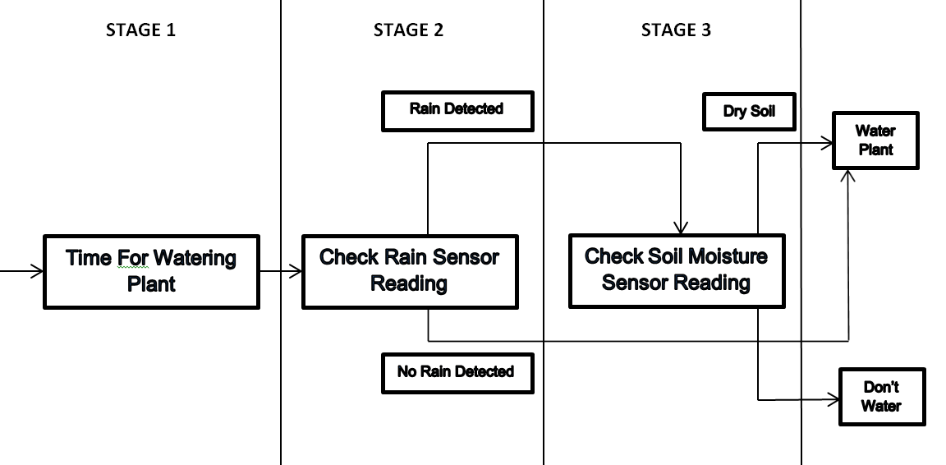

Fig. 2. Block diagram for Smart Garden work path

As seen in Fig. 2. Our device works following a 3 stage pathway that ultimately allows it to make the decision of whether to water the plant or not. The first stage of the whole work path waits for a specified time. For a healthy and proper growth of plants, watering it two times a day is generally accepted [3]. Therefore, STAGE 1 of the device will wait until a specified time of the day (determined by the user) clocks in. At this point, the device will move on to STAGE 2.

In STAGE 2, the Raspberry will process the readings from the Rain Sensor and decide its next move. The main objective of the Rain Sensor is to let the device know if it has rained recently or not. If it has not rained recently, it would mean that the soil is dry and the device will immediately start watering the plant. However, the scenario is slightly different when rain detected. If the Rain sensor shows that it has rained recently, the Pi will move on to STAGE 3.

In STAGE 3, the Raspberry will check the readings from the Soil Moisture Sensor to determine the condition of the soil. This double checking is needed in order to ensure that the soil is actually wet or not. In some cases, the intensity of the rain might be so low that even though it was detected by the Rain Sensor in STAGE 2, the soil moisture at root level still remains below acceptable levels. The Moisture Sensor will let the device know if the soil is dry or wet. If it is wet, the device will skip the water cycle, alternatively, if it is dry, the device will continue watering the plant.

Once the watering cycle starts, the Moisture Sensor itself acts as a threshold, letting the device know when to stop watering. When the moisture level at root reaches satisfactory levels, the Moisture Sensor will display a reading of “Wet Soil”, which will stop the device from watering the plant further. All of these actions are controlled via scripts written in Python 2.7.
4 Experimental Setup and Result Analysis
The main data processing chip used in the project is the Raspberry Pi system, which is an RISC processor designed by Advanced RISC Machines. For the purpose of our project, we have attached a Rain Sensor, a 6V Water Pump and a Soil Moisture sensor to the main board. The Raspberry Pi does not come with an built-in storage solution, therefore an SD card is used for booting the OS and long term storage of data. The Linux Debian operating system named “Raspbian” for our project.

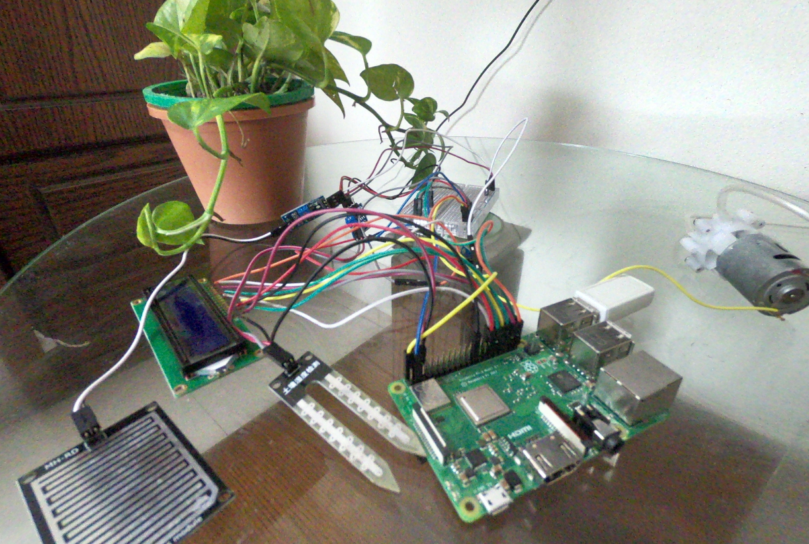

Fig.3. This image shows the actual set-up that we are using for our prototype. The Raspberry Pi 3 Model B+ is connected to the Soil Moisture Sensor, Rain Sensor, LCD Display and a 5V Water Pump (via relay switch) through connections made using an assorted selection of male to male and male to female jumper cables. A breadboard is used as a means of extending the connectivity of the device as well.

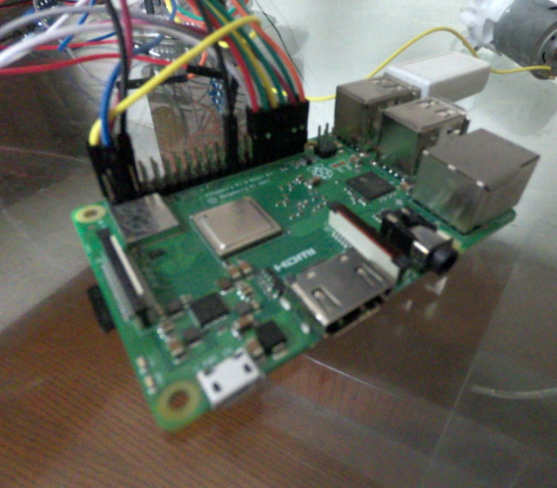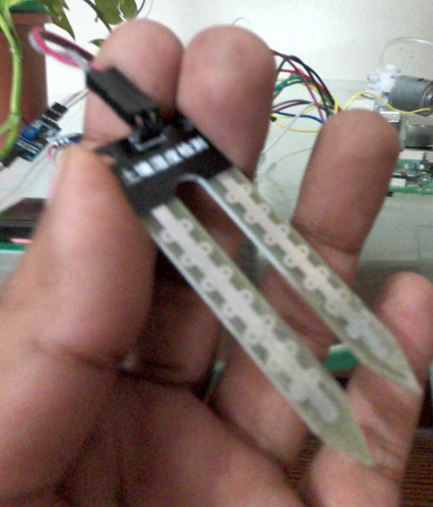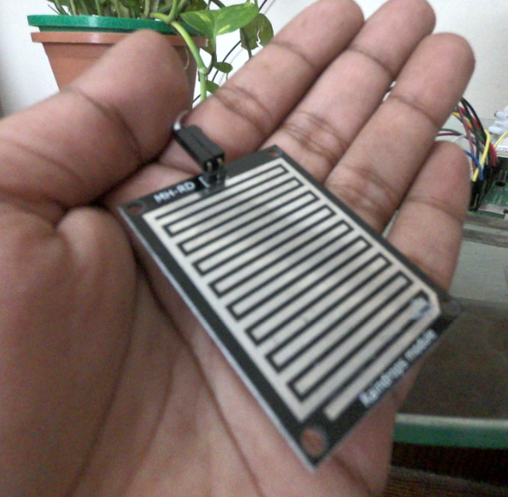
- (b) (c)
Fig. 4(a). This is the image of the Raspberry Pi Model 3 Model B+. Fig. 4.(b). shows the image of the Soil Moisture Sensor that we are using while Fig. 4.(c). shows the Rain Sensor.

For testing out the prototype, we checked it’s workflow on both dry and rainy environment to ensure maximum accuracy. When there were no simulated rain effects and the soil was previously dry, we were able to notice that the signal light from the Soil Moisture sensor stayed off. When the specified watering time came and the device detected that the Soil Moisture Sensor remained off (indicating a dry soil), the device automatically started the water pump which watered the plant up until the Soil Moisture Sensor’s moisture indicator turned on (indicating a wet soil).

Alternatively, when we tried to simulate the effects of rain, we intentionally kept the soil of our plant dry. In this scenario, the Soil Moisture Sensor’s indicator remained off at first. After introducing rain to the scenario, the indicators of both the Soil Moisture Sensor and Rain Sensor lit up (indicating that it has rained and the soil is wet), which prevented our device from further watering the plant despite the fact that it was watering time for the plant.

These tests were carried out in a multitude of different environments to check the validity and accuracy of the results. Combinations of different plants and soils were used in order to assess the device. In the end, we were able to conclude that our prototype is indeed working as expected and is only watering the plant if the soil is dry.
5 Conclusion
The core aim of our project was to come up with a low cost and effective automated solution that would benefit both gardeners and plant cultivators to water their plants with ease. With our provided automated solution, individuals from both fronts will be able to rest easy, knowing that their plants are being watered properly, without the need of any kind of human intervention. The low cost and accessibility of our prototype ensures that it can be implemented into any Garden or Horticultural Farm with ease. We strongly believe that further improvements can be made in this project as well in many ways. A light sensor could be added in order to detect the light requirement of the plants and automatically provide it sufficient light through automated fluorescent bulbs mimicking sunlight. This would be extremely helpful during dark or cloud days.
References
1. Childs E.C.: The Use Of Soil Moisture Characteristics In Soil Studies. 4rth Edition, Soil Sciences (1940)
2. Edlefsen, N.E., Alfred, B.C.: Thermodynamics Of Soil Moisture. Hilgardia 15(2): 31-298 (1943)
3. Heber Green, W., & Ampt, G. (1911). Studies on Soil Phyics. The Journal of Agricultural Science, 4(1), 1-24. doi:10.1017/S0021859600001441
4. Larson M., Small E., Gutmann D., Braun J,.: Use of GPS receivers as a soil moisture network for water cycle studies. Hydrology and Land Surface Studies (2008)
5. Williams S.T., Shameemullah M,. Mayfield C.I.: Studies on the ecology of actinmycetes in soil - The influences of moisture tension of growth and survival. 2nd edition, Soil Biology and Biochemistry (1972)
6. Nemali S., Van Iersel W.: An automated system for controlling drought stress and irrigation in potted plants. 3rd edition, Scientia Horticulturae (1972)
7. Richards L.A,.: Methods of Measuring Soil Moisture Tension. 1st edition, Soil Sciences (1949)

